**TASK 2**

**Name:** Swetha M

**Rollno:** 22CSR217

**Step 1:** Install docker by using the command such as

sudo apt-get update

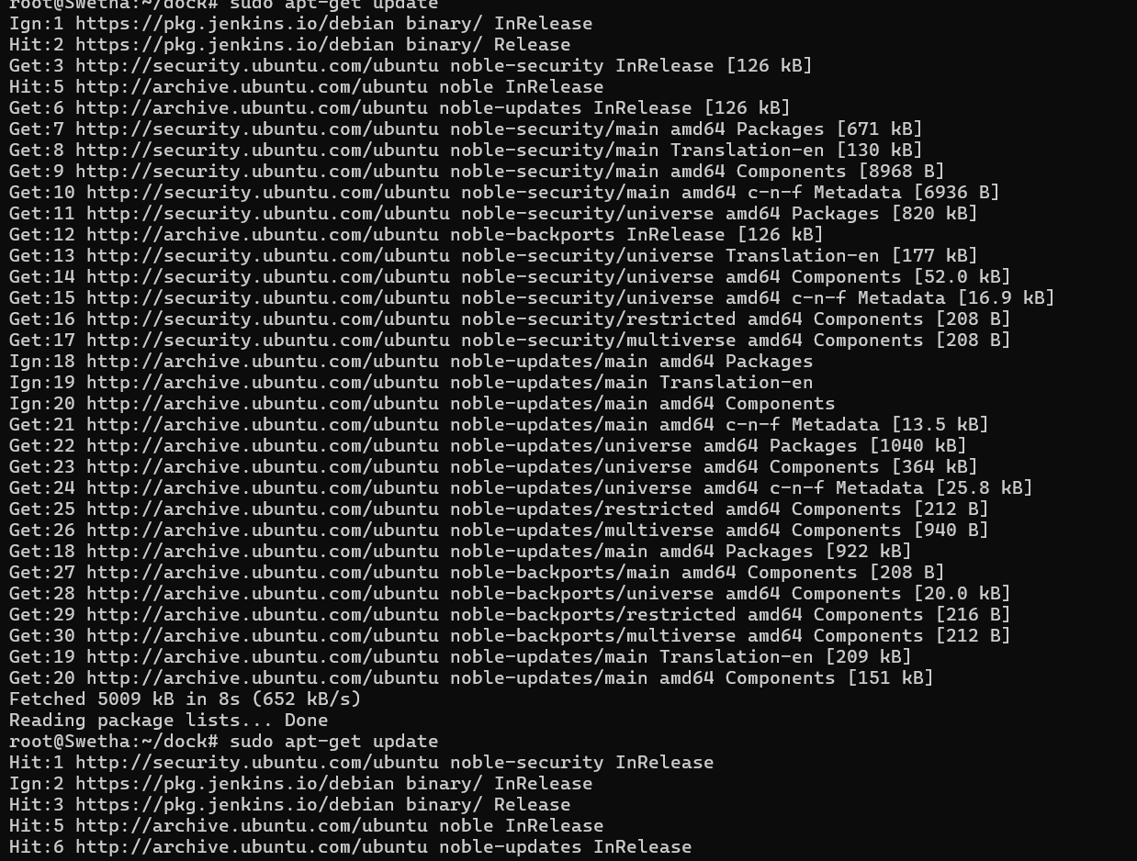

**Step 2:** Push the code into github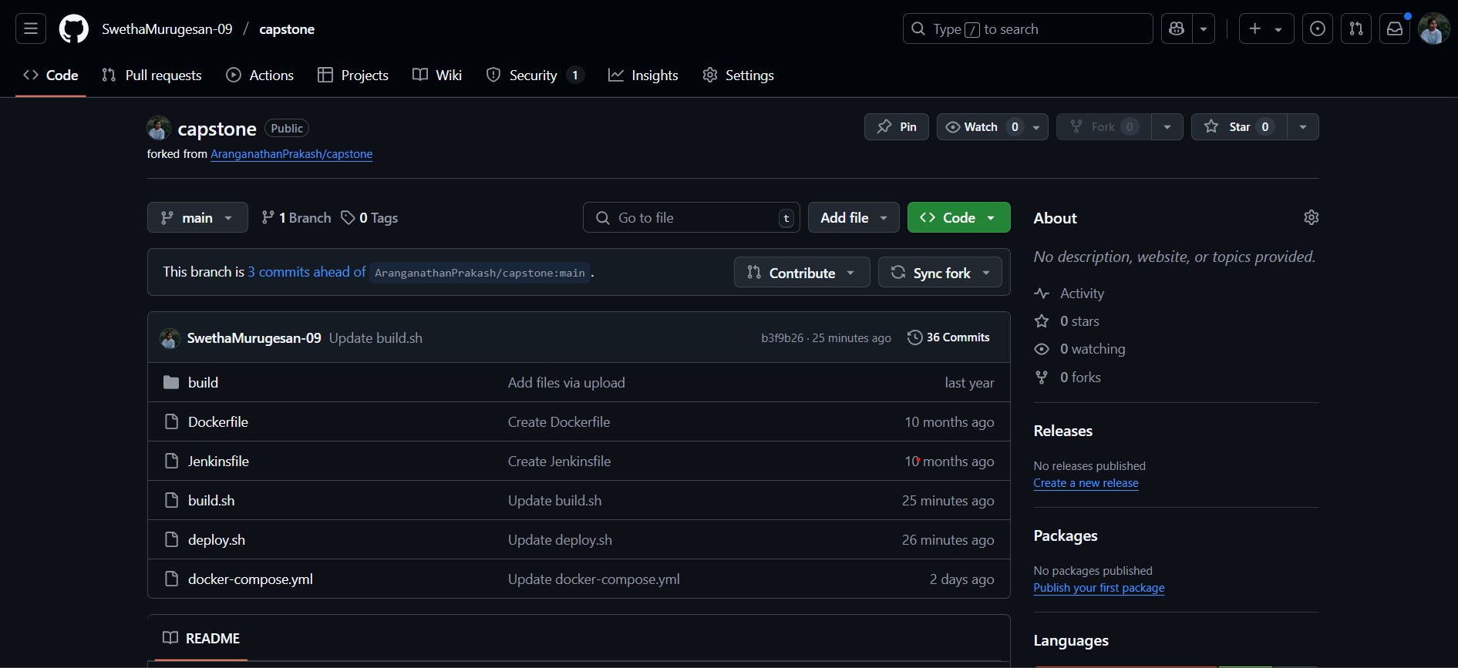

**Step 3:** Create a new item in Jenkins by giving an item name ad select an item type as pipeline

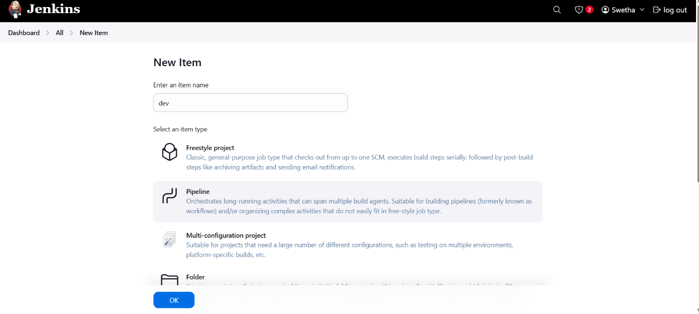

**Step 4:** Give the repository url and branch name and script pathfrom github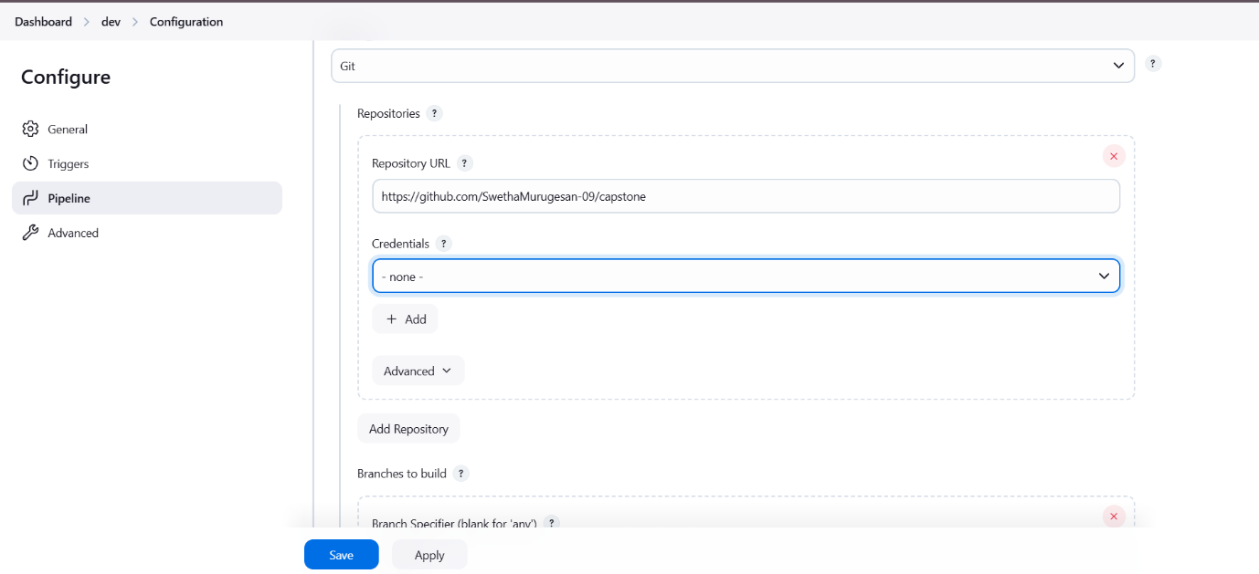

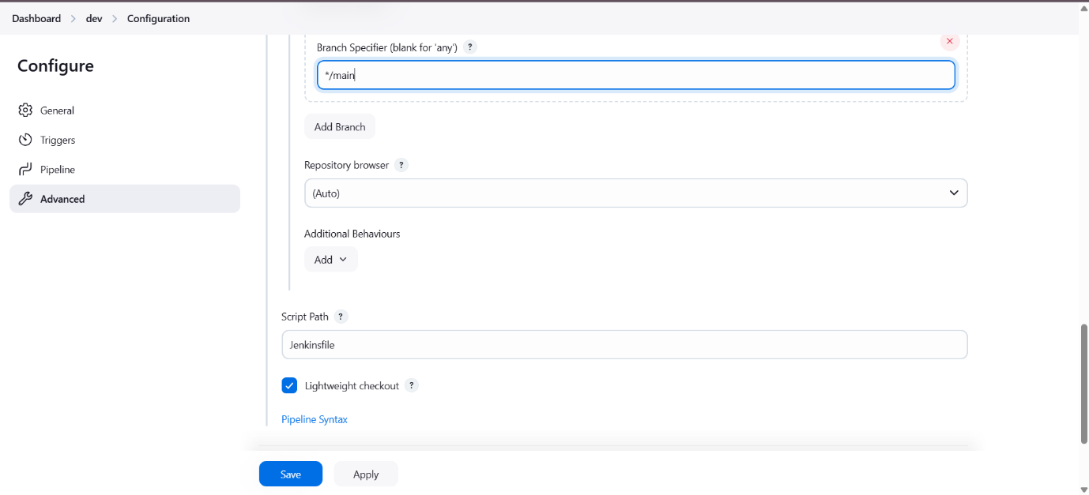

**Step 5:** Give build now in dashboard , it will build the project

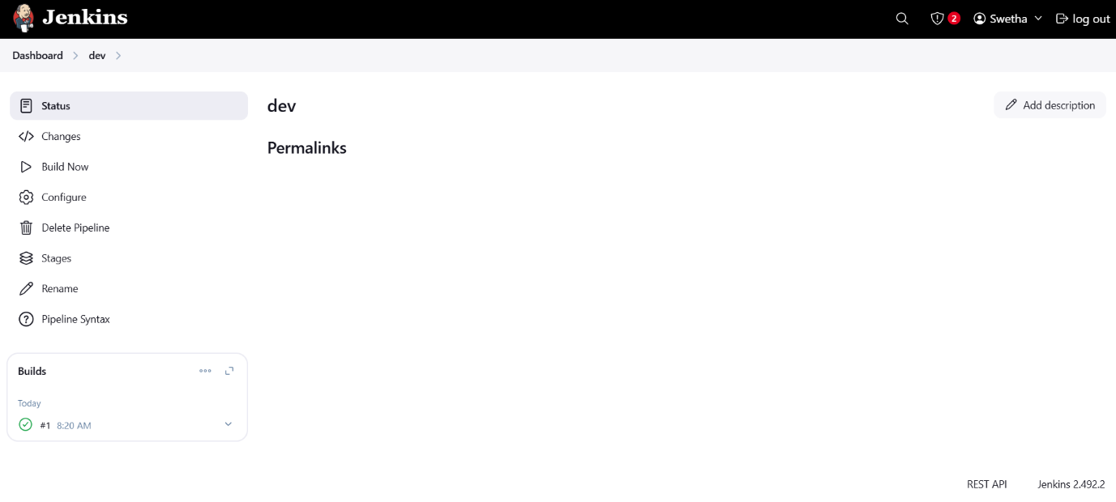

**Step 6:** Check the console output to verify whether it is builded correctly

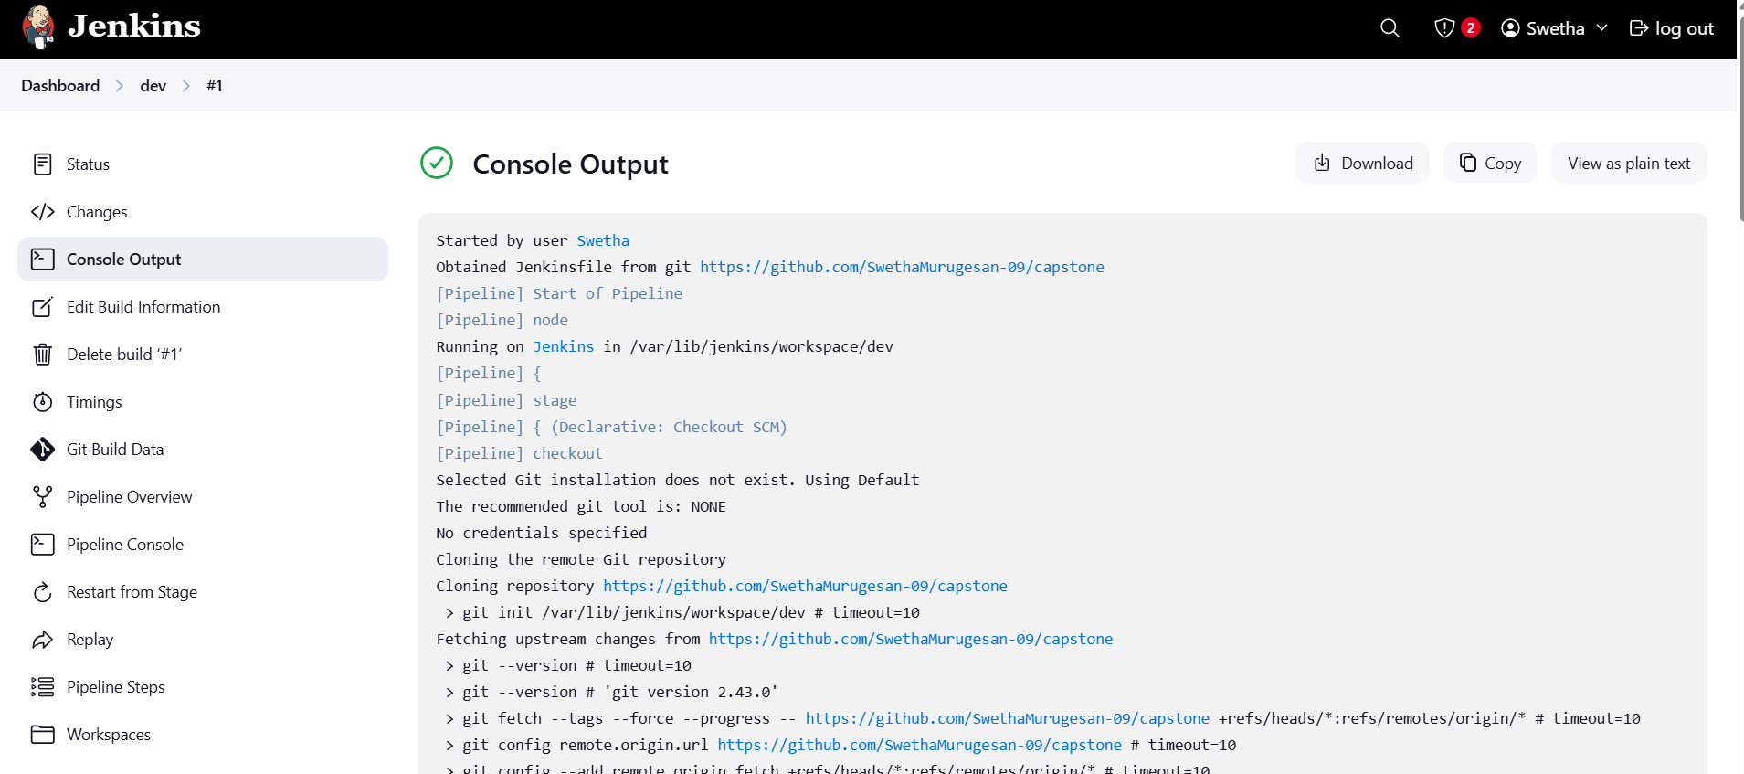

**Step 7:** Run the command to see the output in localhost

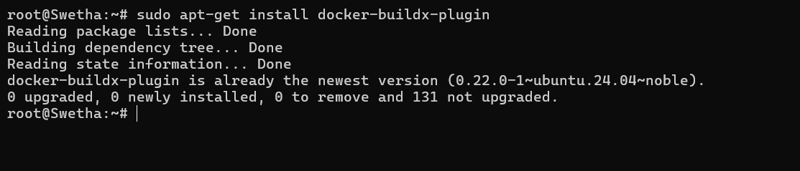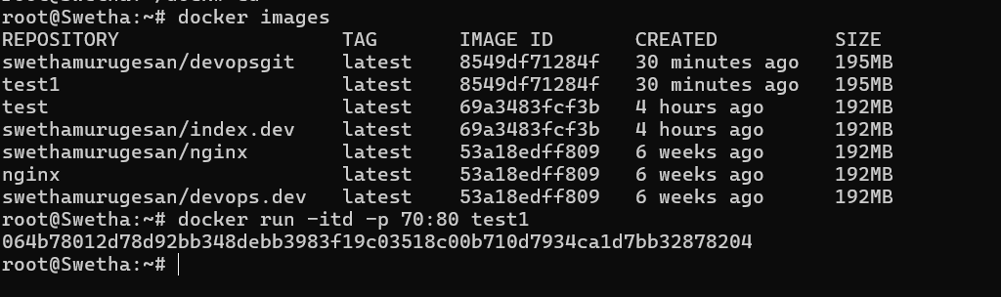

**Output:** 